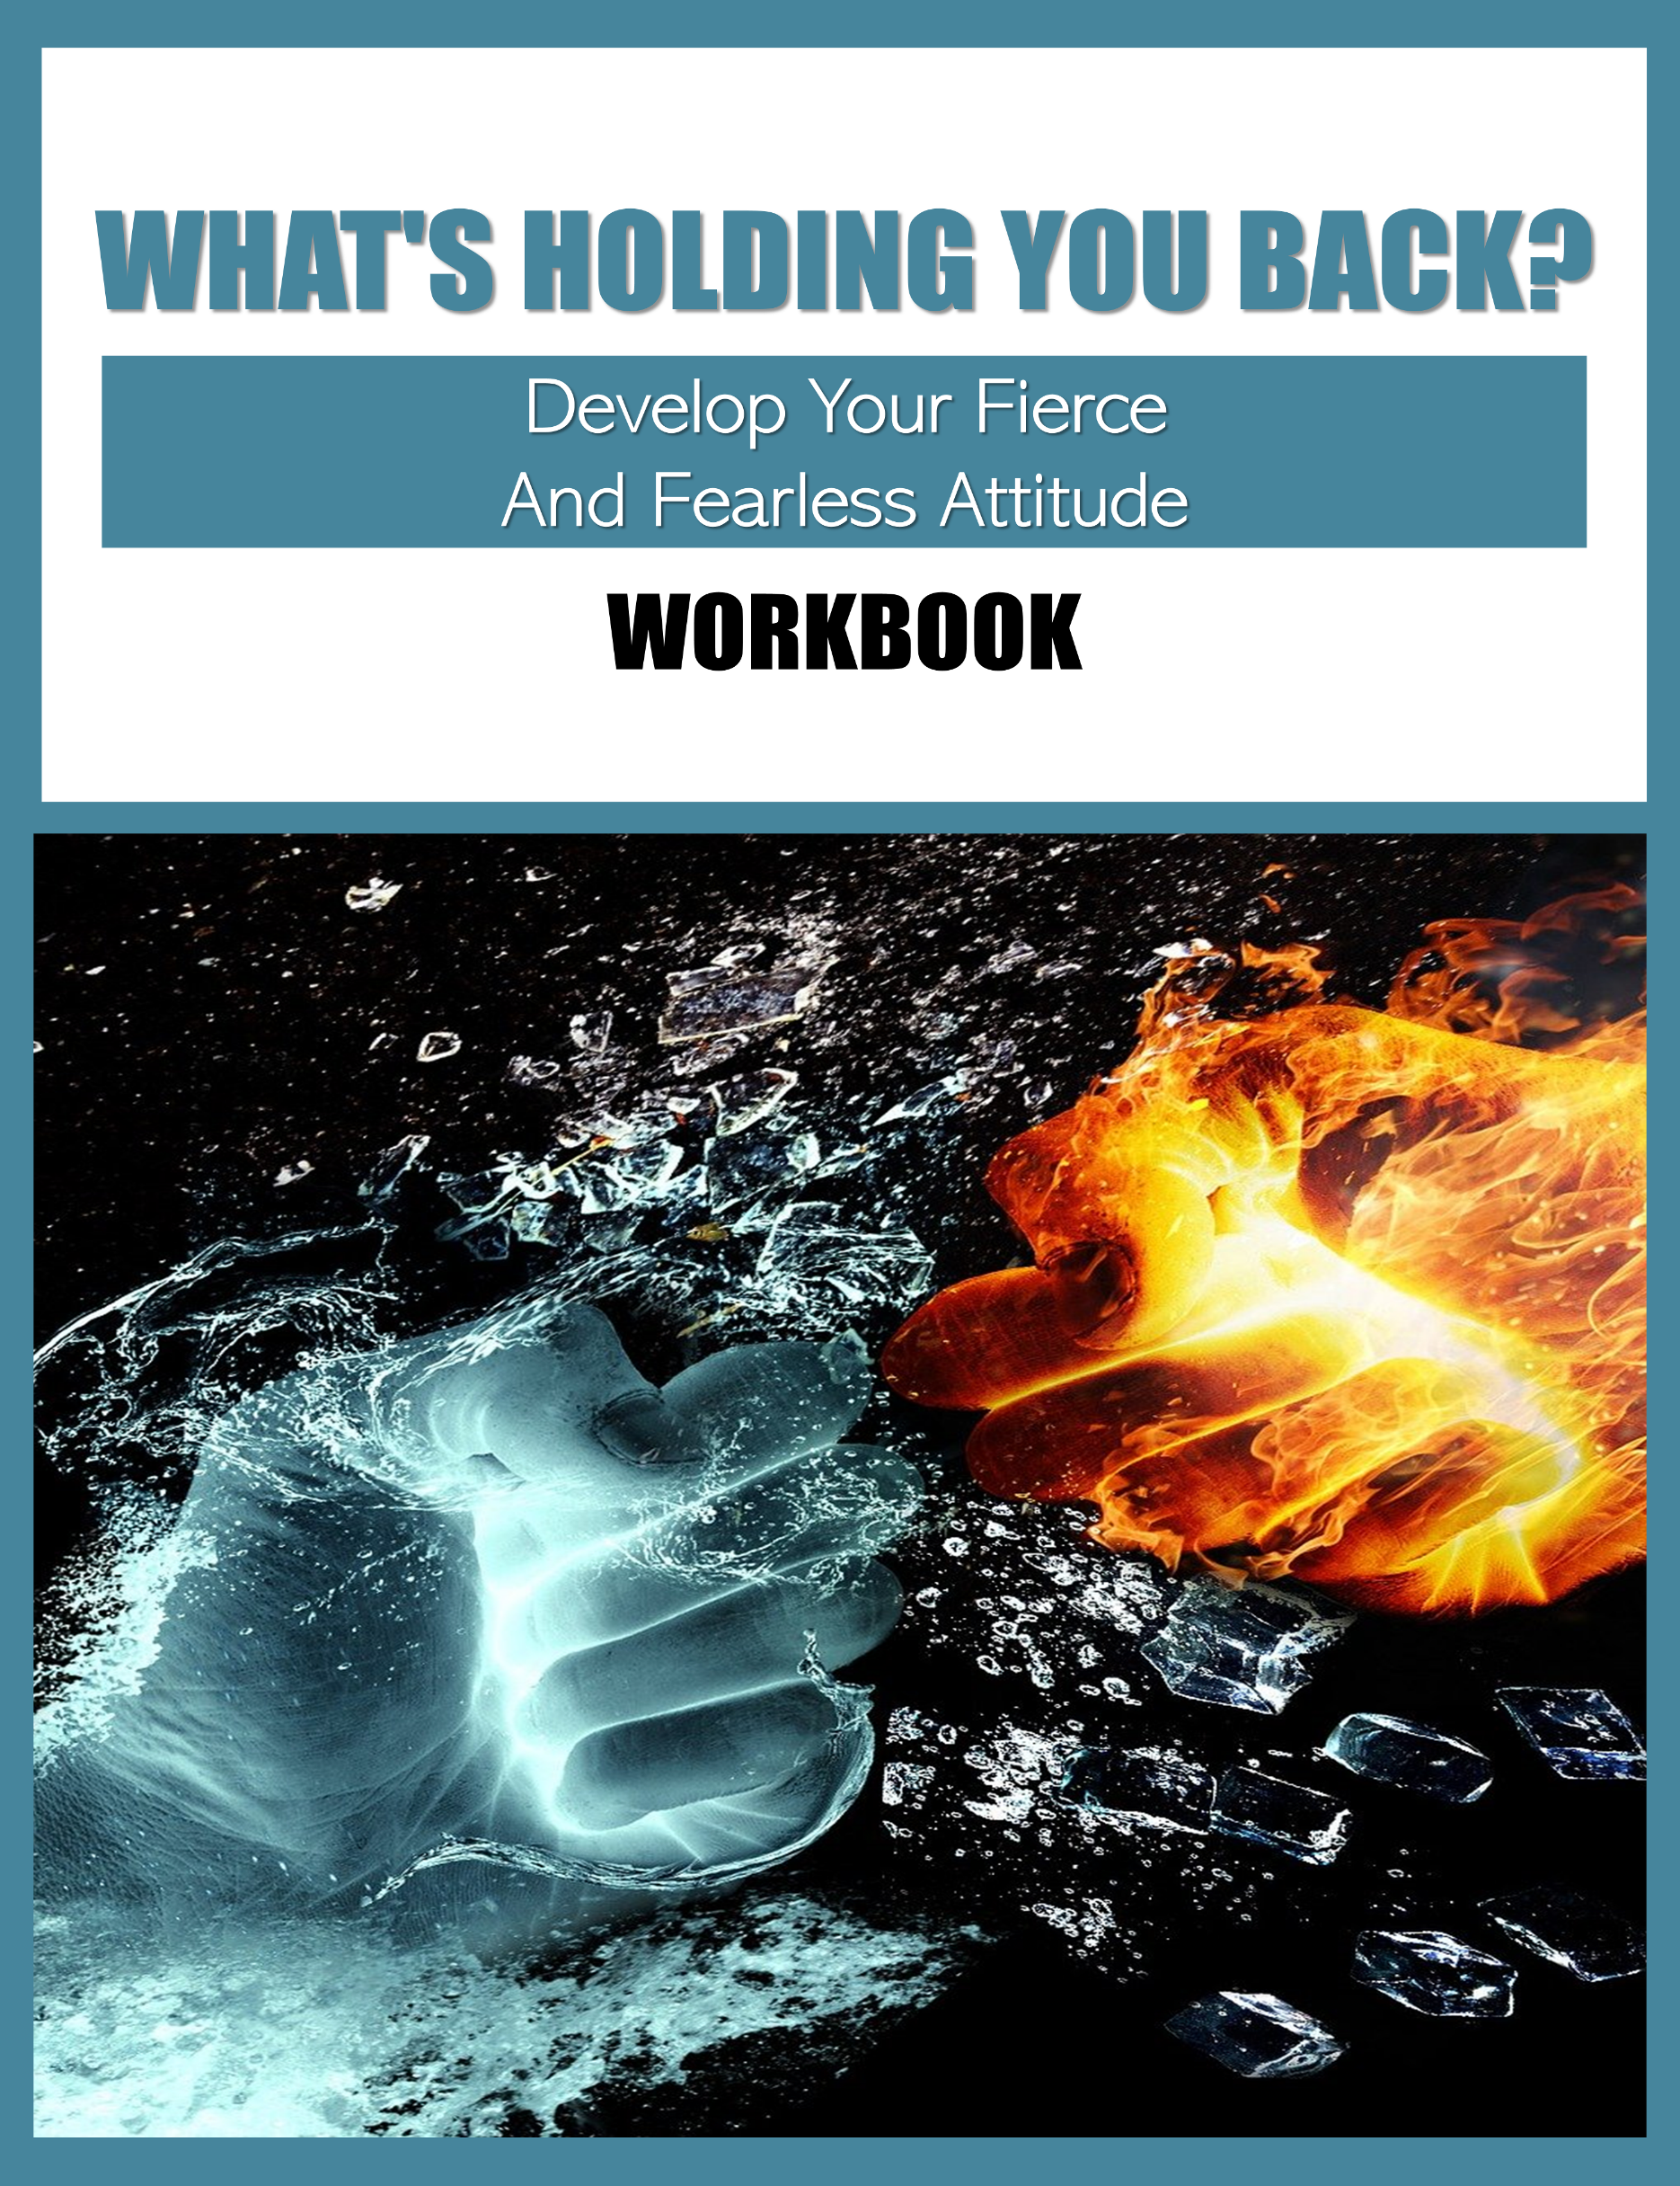
Table Of Contents
Introduction 1
Exercise One 2
Think about the last thing that made you feel truly scared, frightened, or afraid. Describe what that fear felt like: 2
During the event that made you feel your fear, what other emotions were you experiencing? 5
Think back further into time. When was the first (or at least the earliest) time you can recall feeling fear from this particular stimulus? 8
When you experience fear over this particular stimulus, what other sensations do you notice in your body? (For example, this can include a tightness in your chest, rapid breathing, an urge to run away, etc.) Describe your other sensations: 11
When you consider your entire experience with this particular fear – from your initial meeting with the stimulus that causes it, your personal reactions, and your emotions – how do you feel about the fear experience? 14
What do you notice most about yourself when you’re experiencing this fear? 17
Exercise Two 20
Pretend you are outside of your own body for a moment. In this out of body experience, pretend you are watching yourself react to a particular fear you have. What is your reaction to seeing yourself worry about this particular fear? 20
Create a pros and cons list about how you typically react to your fear. Use the chart below to explore the pros and cons of your specific situation. 24
After examining the pros and cons of your fear, ask yourself the following: Is this fear protecting me from a real threat or merely a perceived one? 25
Think about facing your particular fear. In the best case scenario, what would happen if you faced your fear? In the worst case scenario, what would happen if you faced your fear? 28
Pretend your best friend is experiencing conflict with the same fear as you. As a supportive friend, what would you tell them to help them feel better? Why would you say these particular things to help comfort your friend? 31
Exercise Three 34
Think about one of your biggest fears. What is the specific trigger that makes your fear initiate? 34
What is your fear’s number one top priority? Why do you believe this particular priority is so important to your fear? 37
According to your fear, what is the absolute worst thing that could happen to you? At the very center of your fear, what is the most concerning or troubling situation your fear believes you could become involved in? 40
Do you feel like your fear exists to serve you or hinder you? 43
If you could tell your fears anything you wanted, what would you say to them? 48
Exercise Four 51
Begin this process by writing down a general list of your core beliefs and values. 52
Are there any particular types of situations or scenarios that cause you to act in a negative and/or toxic way? If so, describe those situations: 55
Do you have any specific memories from your childhood that affect the way you perceive yourself? If so, describe those memories below: 58
Consider different areas or aspects of your life where you feel the most challenged (these can be specific social scenarios, emotional challenges, etc). 61
Think about everything you’ve discussed so far in prompts 1-4. In each of those areas, which of your personal beliefs can connect to why you act and/or feel in those specific ways? 64
JOURNAL/NOTES 69

Disclaimer: The information contained in this publication is strictly for informational purposes. Every possible effort has been made in preparing and researching this material. We make no warranties with respect to the accuracy, applicability of its contents or any omissions.

Introduction
Having a go-getter, fierce, and fearless attitude is highly valuable. When you aren’t afraid to go after what you really want most in life, you can feel like nothing will ever bring you down.

With that type of attitude, your only limitation in life is how big you allow your dreams to be!

Unfortunately, many people have a hard time achieving this level of go-getter fierceness with their attitudes. For a variety of reasons, people can feel intimidated or shy about approaching a situation fearlessly in order to get what they really want out of life.

If you struggle to face your fears and go after what you want in life, it is possible to work through those challenges and find your fearlessness.

With some time, practice, and determination, you can learn how to overcome the things in your life that hold you back and develop a keener sense of fearlessness and determination.

Exercise One
In this first exercise, you’ll explore your fears. An important step toward understanding what’s holding you back in life, what scares you most, and what challenges specifically stop you from going after what you want is exploring those things!

Exploring your fears is frightening – perhaps you liken it to staring at a monster in the eyes – but doing so helps you develop a concrete image of what it is that scares you and holds you back. With that knowledge, you can begin to develop actionable ways to move forward from those fears. To begin exploring your fears, follow the following prompts.

Think about the last thing that made you feel truly scared, frightened, or afraid. Describe what that fear felt like:

During the event that made you feel your fear, what other emotions were you experiencing?

Think back further into time. When was the first (or at least the earliest) time you can recall feeling fear from this particular stimulus?
What was that first experience like? Describe your memories, emotions, reactions, etc. below:

When you experience fear over this particular stimulus, what other sensations do you notice in your body? (For example, this can include a tightness in your chest, rapid breathing, an urge to run away, etc.) Describe your other sensations:

When you consider your entire experience with this particular fear – from your initial meeting with the stimulus that causes it, your personal reactions, and your emotions – how do you feel about the fear experience?

What do you notice most about yourself when you’re experiencing this fear?

Describe those observations below:

*Note: This exercise can be repeated to explore other specific fears if you have more than one. Simply repeat the question sequence with another fear in mind in the margins of your writing space on the page or on a separate paper.

Exercise Two
Now that you’ve had a chance to analyze your fear (or multiple fears!), it’s time to start taking a more critical look at it. Once you have the data from reflecting on past fear experiences, you can use those observations much like you would in any other situation – looking at that information can give you valuable insight you can use to take an objective look at what’s causing your fears and why they’re holding you back in life.

Think of analyzing your fear experiences like a science experiment. In many grade school classrooms, students can recall scientific experiments where they’d collect data and then use their observations to make hypotheses, draw conclusions, and better understand the scientific processes they were observing.

You can use this same method to take an objective look at your fear patterns. To begin taking an objective look at your fear(s), follow the prompts below:

Pretend you are outside of your own body for a moment. In this out of body experience, pretend you are watching yourself react to a particular fear you have. What is your reaction to seeing yourself worry about this particular fear?

Describe your thoughts and reactions below:

Create a pros and cons list about how you typically react to your fear. Use the chart below to explore the pros and cons of your specific situation.

(The first space is filled in as an example only – if the example doesn’t apply to you, it can be crossed out.)

The specific fear I have is __________________________________________.

Pros + | Cons -
This particular fear stops me from finding myself in an unpredictable social situation. | I rarely ever get to make any new friends.

After examining the pros and cons of your fear, ask yourself the following: Is this fear protecting me from a real threat or merely a perceived one?

Explain your rationale below:

Think about facing your particular fear. In the best case scenario, what would happen if you faced your fear? In the worst-case scenario, what would happen if you faced your fear?

Describe both situations below:

Pretend your best friend is experiencing conflict with the same fear as you. As a supportive friend, what would you tell them to help them feel better? Why would you say these particular things to help comfort your friend?

Describe what you’d say and why below:

Exercise Three
Next, you’re going to focus on your fear’s feelings and priorities. This may seem strange, but yes, your fears often have their own agendas! Unfortunately, those agendas often push hard against the things you really want to achieve in life – that’s why fears often hold you back from doing what you really want to do.

Think of this prompt series as a way to get to understand your fear a little bit better. Like understanding a friend’s reasons and rationale for doing something, understanding where your fears are coming from and their individual agendas makes them easier to pull apart, analyze, and break down.

To begin learning more about your fears’ agendas, follow the prompts below:

Think about one of your biggest fears. What is the specific trigger that makes your fear initiate?

Describe a triggering situation below:

What is your fear’s number one top priority? Why do you believe this particular priority is so important to your fear?

Describe your thoughts and observations below:

According to your fear, what is the absolute worst thing that could happen to you? At the very center of your fear, what is the most concerning or troubling situation your fear believes you could become involved in?

Describe this possibility below:

Do you feel like your fear exists to serve you or hinder you?

Describe your thoughts below:

If you could tell your fears anything you wanted, what would you say to them?

Describe the conversation you’d have with your fears below:

Exercise Four
Identifying the limits you place on yourself is another big obstacle toward moving forward into the future you were meant to have. Often, these obstacles are called “limiting beliefs.”

A limiting belief is a self-imposed belief you have that you cannot or will not ever accomplish a particular thing. For example, someone with limiting beliefs may assume that they’ll never graduate from college, save enough money to purchase the car of their dreams, or work hard enough to earn a big promotion at work.

Because of these limiting beliefs, the person hears these thoughts repeatedly in their minds – after a while of hearing these limiting beliefs over and over again, the person begins to accept them as the truth!

Unfortunately, limiting beliefs have a way of becoming a sort of self-fulfilling prophecy. Because the person automatically assumes their limiting beliefs are true (and they continually repeat those thoughts to themselves), they begin to internally accept that there’s no use trying to work toward their “unattainable” goals. Because they can’t see themselves reaching those achievements, they assume there is no point in trying.

Obviously, having limiting beliefs can hold you back from reaching your fullest potential. To determine whether or not you have limiting beliefs (and if you do, how to begin processing them and breaking them down), follow along with the prompts below:

Begin this process by writing down a general list of your core beliefs and values.

For example, your core beliefs and values can be broad, generalized truths that you believe about the world (sometimes these are religious, family-based, experience-based, and beyond). Jot down your list here:

Are there any particular types of situations or scenarios that cause you to act in a negative and/or toxic way? If so, describe those situations:

Do you have any specific memories from your childhood that affect the way you perceive yourself? If so, describe those memories below:

Consider different areas or aspects of your life where you feel the most challenged (these can be specific social scenarios, emotional challenges, etc.).

Describe why these areas/aspects of your life cause you to feel challenged. What makes these areas difficult for you?

Think about everything you’ve discussed so far in prompts 1-4. In each of those areas, which of your personal beliefs can connect to why you act and/or feel in those specific ways?

Describe those personal beliefs below

JOURNAL/NOTES

